**Neurofeedback therapeutic device of viral infectious disease we using the viral DNA evoked response potential detection in the piriform olfactory cortex**

**Research proposal**

**Justification**

Neurofeedback is not a new concept. It has been the subject of the study of researchers for several decades. Neurofeedback is a method that assists subjects to control their brain waves consciously. In fact, the electroencephalography (EEG) is recorded during the neurofeedback treatment. Then, its various components are extracted and fed to subjects using an online feedback loop in the form of audio, video or their combination. Accordingly, electrophysiological components are separately demonstrated. As an illustration, the power of a signal in a frequency band can be shown by a varying bar graph. During this procedure, the subject becomes aware of the changes occurring during training and will be able to assess his/her progress in order to achieve optimum performance. For instance, the subject tries to improve the brain patterns based on the changes that occur in the sound or movie. Neurofeedback treatment protocols mainly focus on the alpha, beta, delta, theta, and gamma treatment or a combination of them such as alpha/theta ratio, beta/theta ratio, etc. (Dempster, 2012; Vernon, 2005). However, the most commonly used protocols are alpha, beta, theta, and alpha/theta ratio. In this review paper, we discussed various technical and clinical details of different neurofeedback treatment protocols.

This proposal suggests establishment of new technology to have the critical pandemic eliminated or solved either , as the pharmaceutical solutions have been challenged due the rapid mutation of the virus . based on the researches studies and the experiments showed that observation of the virus only inter the cell through the( angiotensin converting Enzyme 2 receptor) ACE2 , and the challenging is always magnified with the virus proliferation and spread in inside the body , this research aim to stop this proliferation by critically study the ion channel activity and measurements the virus accessory protein potential and membrane currents , considering the selective gated current . By having the virus accessory protein activities in the ion channel observed ,controlled, simulated and modified stimulated .the research suggests that the sympathetic nervous system indications of the Cov-SARS2 accessory proteins set of actions monitored by using the dynamic voltage clamp based Huxley -Hodgkin model, electroencephalogram (EEG) waves spectral analysis on the real time (Brain computer interface ) to predict the simulated waves by using lempel ziv algorithm as tool for the spectral analysis .based on the acquisition date of the host cell electrophysiology during the SARS -Cov binding to the ACE2 and prestige of encoding the virus protein in the host cell . The research aim to have detailed cellular electrophysiological databases that are relevant to the virus existence at least before the cell apoptosis (critical timing of event to be observed) . Then we have the reaction recorded and filtered with (DAQ) data acquisition system . The framework will be discussed at the methodology and tool .

**Keywords : molecular biotechnology , neuroscience , virology, tissue engineering , EEG wave spectral analysis , dynamic clamp, Hodgkin Huxley Model , deep bran stimulation**

**Introduction**

Severe acute respiratory syndrome coronavirus (SARS-CoV), a member of the genus Betacoronavirus within the family Coronaviridae, is an enveloped virus with a single-stranded positive-sense RNA genome of approximately 30 kb in length. The 5′ two-thirds of the genome encodes large polyprotein precursors, open reading frame (ORF) 1 and ORF1b, which are proteolytically cleaved to generate 16 non-structural proteins (Tan et al., 2005). The 3′ one-third of the genome encodes four structural proteins, spike (S), envelope (E), matrix (M) and nucleocapsid (N), and non-structural proteins, along with a set of accessory proteins (3a, 3b, 6, 7a, 7b, 8a, 8b, and 9b) (Perlman and Dandekar, 2005; Tan et al., 2005). SARS-CoV is the etiological agent of SARS (Drosten et al., 2003; Fouchier et al., 2003; Ksiazek et al., 2003; Kuiken et al., 2003; Peiris et al., 2003). At least 8,098 laboratory-confirmed cases of human infection, with a fatality rate of 9.6%, were reported to the World Health Organization from November 2002 to July 2003. High levels

BCI is an EEG-based communication device. VE is a human-computer interface system with which users can virtually move their viewpoint freely in real time. The purpose of using VE is to construct a virtual environment with natural interactivity and to create a real sensation from multimodality. Three-dimensional VR is much more attractive and interesting than most of two-dimensional en- vironments.

To date, many studies have been conducted on the neuro- feedback therapy and its effectiveness on the treatment of many diseases. However, there are some methodological limitations and clinical ambiguities. For example, considering the alpha treatment protocols, there are some issues to deal with such as how many sessions are needed before participants can learn to exert an alert control over their own alpha waves, or how many sessions are needed before such training procedures produce the expected effect on the optimal performance, and how long the desired effects last without feedback (long-term effects). Thus, it is necessary to provide standard protocols to perform neurofeedback.

Similar to other treatments, neurofeedback has its own pros and cons. Although it is a safe and non-invasive procedure that showed improvement in the treatment of many problems and disorders such as ADHD, anxiety, depression, epilepsy, ASD, insomnia, drug addiction, schizophrenia, learning disabilities, dyslexia and dyscalculia, its va- lidity has been questioned in terms of conclusive scientific evidence of its effectiveness. Moreover, it is an expensive procedure which is not covered by many insurance com- panies. It is also time-consuming and its benefits are not long-lasting. Finally, it might take several months to see the desired improvements (Mauro & Cermak, 2006).

**Synaptic Organization of Anterior Olfactory Nucleus Inputs to Piriform Cortex**

Odors activate distributed ensembles of neurons within the piriform cortex, forming cortical representations of odor thought to be essential to olfactory learning and behaviors. This odor response is driven by direct input from the olfactory bulb, but is also shaped by a dense network of associative or intracortical inputs to piriform, which may enhance or constrain the cort- ical odor representation. With optogenetic techniques, it is possible to functionally isolate defined inputs to piriform cortex and assess their potential to activate or inhibit piriform pyramidal neurons. The anterior olfactory nucleus (AON) receives direct input from the olfactory bulb and sends an associative projection to piriform cortex that has potential roles in the state-dependent processing of olfactory behaviors. Here, we provide a detailed functional assessment of the AON afferents to piriform in male and female C57Bl/6J mice. We confirm that the AON forms glutamatergic excitatory synapses onto piriform pyramidal neurons; and while these inputs are not as strong as piriform recurrent collaterals, they are less constrained by disynaptic inhibition. Moreover, AON-to-piriform synapses contain a substantial NMDAR-mediated current that prolongs the synaptic response at depolarized potentials. These properties of limited inhibition and slow NMDAR-mediated currents result in strong temporal summation of AON inputs within piriform pyramidal neurons, and suggest that the AON could powerfully enhance activation of piriform neurons in response to odor.

The piriform cortex provides a simplified circuitry for studying cortical-sensory integration and the influences of intracortical information on cortical sensory representations. Within the piriform, odors activate unique and sparsely distributed ensembles of neurons, forming a cortical representation of odor (Poo and Isaacson, 2009; Stettler and Axel, 2009; Roland et al., 2017). These ensembles are formed in part by distributed inputs from the olfactory bulb, which drive powerful excitatory inputs onto piriform principal neurons (Franks and Isaacson, 2006; Suzuki and Bekkers, 2006, 2011; Davison and Ehlers, 2011). In addition, there is a significant contribution from intracortical or associative

Here, we focus on another major class of associative inputs to piriform with potential to shape the cortical odor representations: the inputs from the AON. The AON is the earliest cortical olfactory area. It receives direct olfactory bulb input from mitral and tufted cells. AON neurons respond to multiple odors, and likely integrate convergent inputs from multiple olfactory bulb glomeruli (Lei et al., 2006). From prior anatomic studies (Haberly and Price, 1978b) and more recent optogenetic assays (Hagiwara et al., 2012), it is known that the AON provides significant excitatory input to the piriform cortex. Additionally, recent studies of the centrifugal projections from the AON to the olfac- tory bulb indicate that the AON preferentially synapses onto bulbar inhibitory neurons, and therefore drives significant inhibition onto mitral cells, which may dynamically filter signal-to- noise for odors according to cortical output (Boyd et al., 2012; Markopoulos et al., 2012). Moreover, the AON is potentially an important area for behaviorally relevant top-down control by neuromodulators or limbic circuits, and may be a critical media- tor of state-dependent olfactory behaviors (Aqrabawi et al., 2016; Oettl et al., 2016).

We provide a functional isolation and quantitative characterization of AON projections to piriform, yielding insight into the potential influence of AON on piriform activity. Using viral vectors for focal and robust expression of channelrhodopsin-2 (ChR2) in the AON, we selectively activated AON afferents to piriform cortex (Boyden et al., 2005; Zhang et al., 2006; Yizhar et al., 2011). Through in vitro patch-clamp electrophysiology, we characterized the basic synaptic properties of AON synapses onto their piriform targets.

Comparisons with piriform recurrent inputs. Synaptic response data from our prior study of piriform recurrent collaterals were included only for comparison of AON responses within piriform (see Figs. 2, 4). These data were obtained identically to the methods outlined above, with the exception that dual viral vectors were injected into piriform cortex for expression in anterior piriform cortical neurons (Franks et al., 2011).

Data analysis. Data were collected and analyzed offline using a combination of Axograph X (Axograph), IGOR Pro (Wavemetrics), MATLAB (The MathWorks), and Prism (GraphPad). Average responses were calculated from 12-20 consecutive episodes. Synaptic time con- stants were determined from a monoexponential best fit when appropriate. Half-width duration was used as a metric of synaptic time course when the response was only well fit by a multiexponential process, as in the case of rapid attenuation of EPSPs by inhibition. Synaptic conduct- ance (Gexcitation or Ginhibition) was calculated from G = PSC/(Vhold Erev) where reversal potentials Erev were theoretical and calculated from the ionic compositions of the intracellular and extracellular solutions (Erev, excitation = Erev, NMDA = 5mV and Erev, inhibition = 92mV). Statistical tests were unpaired or paired two-sided t tests, as appropriate, except where data were clearly not normally distributed, as in EPSC amplitudes in across neurons, in which case Mann–Whitney U test (i.e., Wilcoxon rank sum test) was applied. Each applied statistical test is indi- cated in the text and/or figure legends.

**Functional topography of AON afferents to piriform cortex**

The layer-specific topography of AON afferents to the piriform cortex was previously studied with classic tract-tracing methods (Haberly and Price, 1978b), with results consistent with the pat- tern of YFP1 fluorescent axons that we observed (see Fig. 1D). We sought to determine whether this corresponds to a functional bias of AON synapses for the proximal apical dendritic domain of piriform pyramidal neurons, or whether significant activation may arise from AON fibers in layer 3, or even the sparse fibers observed in layer 1a (i.e., the distal dendritic domain). We used an established method to precisely map single AON synaptic inputs onto piriform pyramidal neurons (Petreanu et al., 2009). With a 470 nm laser directed by scanning mirrors, we illumi- nated highly focused areas within the brain slice along the soma- todendritic axis of piriform pyramidal neurons (Fig. 3A). We included TTX in the bath to block action potentials to restrict photoactivation to synaptic terminals and included 4-AP to block potassium channels and enhance the local ChR2-mediated depolarization. A grid pattern of illumination was chosen to completely sample the apical and basal fields, from the LOT to deep layer 3, of the recorded neuron at center (Fig. 3A, right). Stimulation points were horizontally and vertically separated by 80mm. An exemplary set of responses is shown in Figure 3B. Here, synaptic responses (or absence of response) are plotted at the corresponding point in the stimulus grid that evoked the response. A spatial convolution of the response amplitudes is generated for visualization (Fig. 3B, right).

We scanned the dendritic fields of 12 neurons, with measure- ments of EPSC amplitude at each site, and aligned these maps so that data from 12 neurons could be combined into an average in- tensity profile (actual scan area was larger than that shown here to allow alignment without artifact, and negative responses at the periphery were omitted). Piriform neurons were most strongly activated by stimulation of AON inputs over the proximal apical dendritic field in layer 1b (Fig. 3C). The maximal response for each of the 12 neurons tested is indicated at its corresponding location in a single grid, which shows that most maximal responses occurred in the apical field of the neuron, and that these also tended to be much larger in EPSC amplitude than responses in the basal field (Fig. 3D). There are several neurons with responses in the basal field or layer 3, which suggest some degree of input from the layer 3 fibers seen in Figure 1D. There were no responses observed with focal illumination over layer 1a, the bulbar input layer.

**2. Olfactory Event Related Potentials**

THE INSECT OLFACTORY SYSTEM

Mature insect olfactory neuropils exhibit a remarkably high degree of structural plasticity associated with specific behaviors (Withers et al., 1993; Heisenberg et al., 1995; Ott and Rogers, 2010; Kraft et al., 2019).

The locust is an accessible animal for the analysis of circuit mechanisms of olfactory coding strategies. Each locust antenna is equipped with 50,000 olfactory receptor neurons (ORNs) whose axons project into the antennal lobe (AL), the primary olfactory center (Ernst et al., 1977; Figure 1). The wiring of the insect AL shares common features with the vertebrate olfactory bulb (Strausfeld and Hildebrand, 1999). As in the olfactory bulb, in the insect AL ORNs synapse with local interneurons and olfactory projection neurons (vertebrates: mitral- and tufted cells) in spherical neuropil compartments termed glomeruli. The axons of the olfactory projection neurons (PNs) exit from the AL and project toward the mushroom body and the lateral horn (Laurent and Naraghi, 1994; Anton and Hansson, 1996; Hansson and Stensmyr, 2011). In the calycal compartment, PNs provide excitatory input to subsets of ca. 50,000 densely packed Kenyon cells, the intrinsic neurons of the mushroom body. Similar to mammals, in most insects each olfactory receptor neuron expresses only a single olfactory receptor gene. The receptor neurons expressing the same olfactory receptor gene converge their axons to the same glomerulus in the AL. Consequently, the number of receptor genes roughly corresponds to the number of glomeruli.

The locust uses a different wiring strategy in its olfactory system. Although the locust genome contains about 174 olfactory receptor genes (142 odorant receptors plus 32 ionotropic receptors, Wang et al., 2015), the AL comprises roughly 1,000 glomeruli (Ernst et al., 1977; Anton and Hansson, 1996).

The OERPs, as the other evoked potential, are poly-phasic signals generated in the brain in response to the activity of the cerebral cortex neurons, producing electro-magnetic fields as an electrophysiological response to specific stimuli [30], in this case olfactory stimuli. OERPs can be reliably measured using electroencephalography (EEG), which measures and records instantaneous electrical potential differences between different areas of the brain, through the placement of electrodes on the scalp. Generally, an OERP consists of a waveform characterized by a series of positive or negative components, followed by a late positive component of higher amplitude that is a positive-going event-related brain potential [31]. Figure 1 shows three examples of OERP. The OERP signal is characterized by three main parameters:

• Latency: time interval between the stimulus onset (fixed to 0 ms) and the point of maximum value (peak) of the component;

• Topography: position on the cranial surface where the maximum amplitude of the component can be registered, thus allowing identification of which cortical area is active following a particular stimulus;

• Amplitude: vertical distance measured from the baseline (fixed to 0 μV) to the maxi- mum peak.

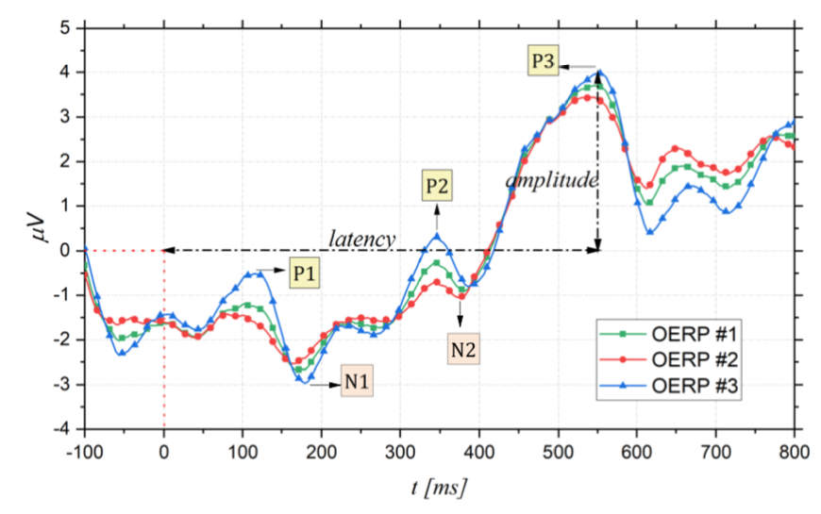

Figure 1. Examples of OERPs: peak amplitude is measured from baseline (0 μV) and peak latency from stimulus onset (0 ms).

Furthermore, as shown in Figure 1, there are different event-related components as the positive peaks named P100, P200, and P300, and the negative peaks as N100 and N200. Their names, usually, indicate wave polarity and absolute latency time after stimulation. Thus, these waves occur at about 100 ms, 200 ms, or 300 ms after the stimulus. However, this absolute latency time is often an approximation, and it can often vary. For this reason, what matters is the latency order, which is why expressions such as P1, N1, P2 and so on, are preferred [32,33]. Analyzing in more detail Figure 1, firstly, there is a small positive response P1, which is not always defined, followed by a large negative response

N2

Bioengineering 2022, 9, 252

N1 (amplitude: −3 μV to −10 μV) and, finally, a large wave P3 (amplitude: +5 μV to +20 μV) [34]. The shape and latency of these event-related potentials allow the detection of sense deficits and the quantification of their severity; moreover, the size of the trace that reproduces the generated potentials changes with stimulus concentration and adaptation phenomenon [31,35]. In more detail, the initial components of the OERP, P1, N1, P2, and N2 are called exogenous sensory components and are related to odor threshold and odor identification [36,37], in particular, the first negativity of the evoked potential corresponds to the nature of the stimulus [34]. On the other hand, the P3 component relates to endogenous stimulus processing and is therefore related to the cognitive processing speed and the ability to evaluate and classify a stimulus [38,39]. When an odorant molecule triggers olfactory cells, after generating a series of alternating positive and negative waves (exogenous components), a later potential (P300) can be measured with electrodes placed over the center

of the scalp in the central and parietal areas [26]. This P300 response is involuntary and, consequently, it is considered more objective than that obtained through psychophysical tests [34]. For this reason, identifying the P300 wave and its characteristics is of paramount importance to obtain information about olfactory function.

With regard to the type of stimulus and to the electrode placement, another important aspect to consider relates to variations in the specific EEG frequency band, compared to the pre-stimulation condition. In this regard, different studies have investigated the effects of the olfactory stimulus on different EEG frequency bands. Although there is an evident alteration of the EEG activity, the frequency band involved is often varied in several studies, likely due to the different methodologies considered. Indeed, in [40], it is shown that the theta frequency band has statistically significant reduction, in agreement with previous studies [41–43]. On the other hand, more recent studies based on time–frequency analysis of the EEG signal consider the gamma band as being associated with smell [44,45].

**Reliability of OERPs**

As discussed in the previous sections, OERP appears to be a more objective diagnostic tool than standard psychophysical testing [46,47]. Nevertheless, in comparison to visual and auditory evoked potentials, widely used very early, OERPs were recorded reliably only at the beginning of the 1980s [48], due to the difficulty in presenting a controlled odorous stimulus, without having a gustatory stimulation. Since then, OERPs have enjoyed increasing popularity in the study of smell disorders. However, the reliability of this measurement strategy was examined only starting from the early 2000s, by test–retest over a 4-week interval with healthy participants [49]. More specifically, this study showed that P2 is related to stimulus characteristics and correlates with olfactory threshold tests [37]; it may, therefore, serve as an indicator in most clinical and experimental studies. Likewise, olfactory P3, having a high level of stability in relation to its temporal occurrence, could suggest the use of P3 latency as a consistent measure of central olfactory function.

Thereafter, the reliability of olfactory ERPs in investigating olfactory function was demonstrated in the literature by various studies correlating the electrophysiological assess- ment of olfactory function with concomitant psychophysical assessments. More specifically, OERPs signal are never detected in patients diagnosed with anosmia using psychophysical tests (e.g., Sniffin’ Sticks) but could be present in some hyposmic patients [26,50] but with different characteristics from those of the control. On the other hand, as was reported in the Rombaux study [50], in patients with normal olfactory function, the absence of OERP is probably related to the technical problem, for instance EEG artifacts. Certainly, the odd results of OERP presence in a patient diagnosed as anosmic with psychophysical tests could mean that the patient lied probably for a secondary gain. Table 1 summarizes some of the results from [50].

Similarly, in [51], the OERP responses of patients with olfactory impairment, assessed with psychophysical tests, and healthy controls to odor concentration was evaluated. It was noted that as the stimulus concentration increases, OERP amplitudes increased, and the latencies shortened. Additionally, the analysis on the control group and the patient

**Deep Brain stimulation based Huxley Hodgkin model :**

A series of papers published in The Journal of Physiology in 1952 revolutionized our understanding of neuronal function: Alan Hodgkin and Andrew Huxley used the experimental data from a sequence of papers on voltage-dependent conductances in the squid giant axon (Hodgkin et al., 1952; Hodgkin and Huxley, 1952a– c) to propose a model that accurately predicted the shape of the action potential (Hodgkin and Huxley, 1952d). This pro- vided the first quantitative description of the electrical events underlying action potential generation. However, their model was influential far beyond the generation of action potentials. It created a conceptual basis for at least three levels of research in neuroscience. First, at a molecular level, the Hodgkin-Huxley model established a framework in which to describe the struc- tural and functional properties of ion channels, including the mechanisms of ion permeation, selectivity, and gating. Second, at a cellular level, the model predicted not only the action potential itself, but also the conditions that control the timing of action potential onset, including threshold and refractory periods. Fi- nally, at a circuit level, the predictive success of the Hodgkin- Huxley formalism made it an exemplar of how to use data-based modeling in scientific research and paved the way for the now- thriving field of computational neuroscience.

In this Symposium Review, we aim to show how the Hodgkin-Huxley model inspired and continues to inspire neuroscientific research. With a focus on sodium channels, we will first discuss how the Hodgkin-Huxley model continues to influence research on the structure and function of ion channel We will then discuss the control of action potential tim- ing and synchronization in neuronal information processing, and finally examine the Hodgkin-Huxley model from the per- spective of computational neuroscience.

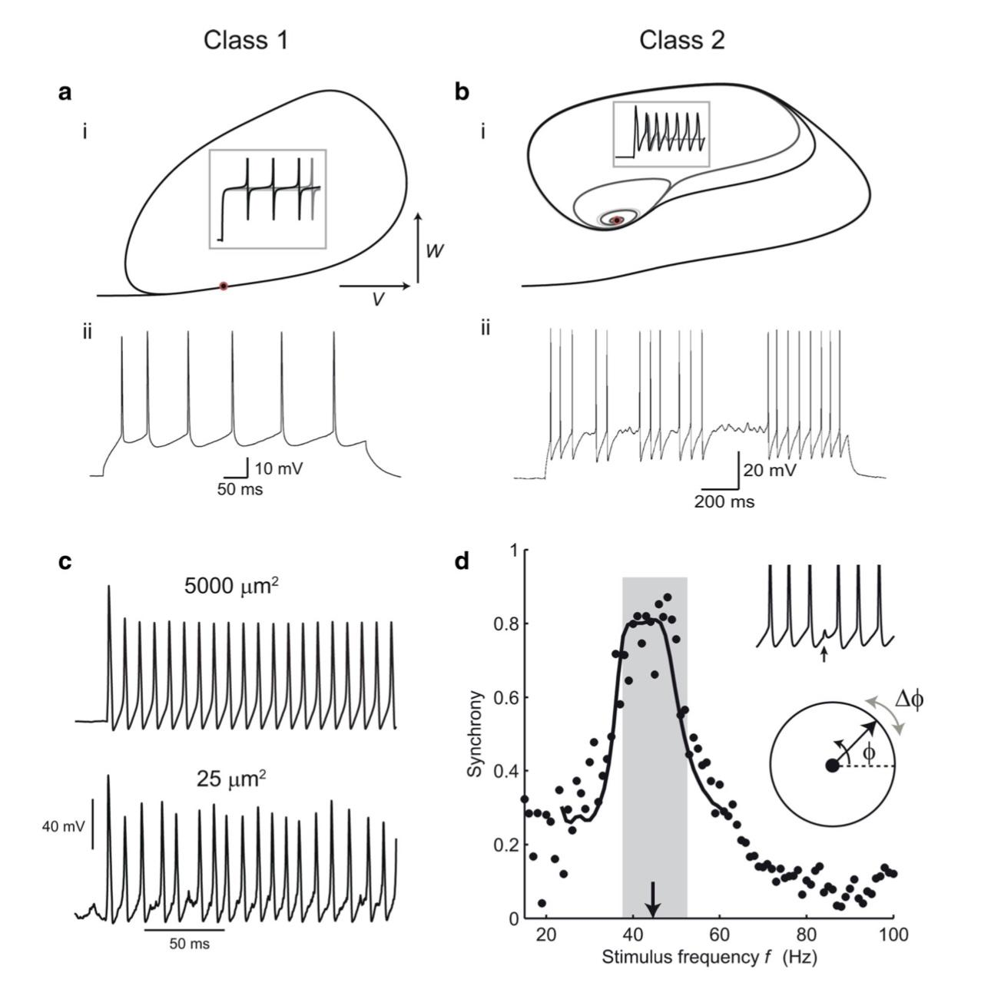

Figure 1 :Applications of Hodgkin-Huxley theory to spike generation and timing in cortical neurons. Class 1 (a) and Class 2 (b) threshold dynamics. ai, The phase plane of the Morris-Lecar model with Class 1 dynamics shows an invariant cycle for responses to current steps just below and above threshold (in this case, all the phase plots lie on top of each other). V, Membrane potential; W, potassium activation or recovery variable. Inset, Voltage versus time responses (spikes are curtailed). Red circle indicates the coalesced fixed points at threshold. aii, Stable low-frequency firing in a nonpyramidal regular-spiking interneuron, which has a Class 1 threshold. bi, Morris-Lecar model with Class 2 parameters. Subthreshold responses spiral in to an attracting fixed point at which the Jacobian matrix of the dynamics has complex eigenvalues. Above threshold, this point becomes repelling. bii, A near-threshold response of a fast-spiking inhibitory interneuron switches between spiking at the threshold frequency and subthreshold oscillations, showing Class 2 behavior. c, Spiking in a stochastic Hodgkin-Huxley model simulated according to the method of Chow and White (1996). Reducing the membrane area and channel numbers results in a much more irregular and variable amplitude response. d, Synchronization can be predicted by phase-resetting functions. Periodic spiking is modeled as a phase variable 􏱊 with constant angular velocity (bottom inset). It is perturbed (􏱉􏱊) by synaptic inputs that change the interval to the next spike (top inset). The synaptic phase resetting function 􏱉􏱊(􏱊) can be used to predict how well the cell synchronizes to inputs of different frequencies (main graph, synchrony is the order parameter—magnitude of the average phase vector—at the times of inputs). Black points are measured data, curve shows theoretical prediction. From Gouwens et al. (2010).

**Hodgkin-Huxley models in computational neuroscience**

The Hodgkin-Huxley model (Hodgkin and Huxley, 1952d) of the action potential in the squid giant axon has served as a foun- dation for models of neural dynamics on a range of spatial scales. At a fine grain, the probabilistic opening and closing of single ion channels can be described by Markov models, which make the assumption that the probability of transitioning between states depends only on the current state (Fink and Noble, 2009). At the next level, which is where Hodgkin-Huxley models apply, the numbers of ion channels are assumed to be sufficiently large that only the average conductances are represented in the equations. This approximation can become inaccurate when the structures are sufficiently small or the numbers of channels small, such as in thin axons and synaptic spines (Qian and Sejnowski, 1990; Faisal et al., 2005), as discussed in the previous section (Fig. 3c). Current digital computers can simulate thousands of Hodgkin-Huxley model neurons with realistic morphologies interacting in realistic circuits (Brette et al., 2007). For these models to accurately rep- resent neural activity, the properties of the ion channels and their locations inside neurons must be known. For yet larger neural networks, the Hodgkin-Huxley equations can be simplified to yield models with many fewer parameters, while retaining some of the complex dy- namics of real neurons (Morris and Lecar, 1981; Izhikevich, 2007). Hodgkin-Huxley neuron models, however, remain the gold standard against which these simplified models are compared.

The research aim to observe the membrane current that produced from the virus protein and ACE2 receptors evoked response signals (piriform olfactory cortex ) of the ligand-binding receptors singnal. These signals to be trained, tested and predictable computerized using it in advanced mathematical and computational algorithm set to utilize it in filtering out any innervated artefact signals other than the signal simulated after the vitro experiment , clustered by reading them from the human dorsal root ganglia , medulla and brain stem as (EEG) map those waves combined together , reading the EEG in the real time algorithm limpel ziv using (synthetic signal data) enables the predictive probability of having SARS -COV evidence of existence , next and in the real time we will use the dynamic clamp (Huxley- Hodgkin) model to synthesized neuronal pulse stimulated based either receptor blockades from the virus or eliminate the the virus during encoding it protein .

Brain computer interface is package library has been stablished in python programming languages specified in (EEG) wave processing, as the EEG only gets the (Beta , Gamma , theta , alpha , Delta ) we aim to cluster these waves based the Envelope protein , 3a protein and 8a proein function in the ion Chanel represented in signal sepcturem that are simulated and our model using it to compare it from the acquisition data . The model will response with pulse stimuli in case we get positive result from the search algorithm (Zip Lempel) is specified for bio signal and EEG sepecteral analysis , ACE2 receptors evoked response parameters however it’s never discussed in the literature the only feature that is been tested the 3a protein and Envelop protein , 8a protein are only the three transmembrain domain have been observed with consensus ion specifity NA+ / K+ except 3a protein K+ only, applying advanced method to discreet the signal until find the spectrum of the wave of those very certain feature of protein transmembrane domain ,whether it indicates the ligand of the enzyme or other activities of RNA encoding the viral protein . Table 1.

**2. Evidence of ion Channel function of Envelope protein :**

The envelope protein E is a small (~8–12 kDa) integral membrane protein, the biological significance of which has been comprehensively reviewed elsewhere (2). It is highly expressed in host cells during viral replication: a minor fraction is incorporated into the virion envelope, while most protein localizes in the endoplasmic reticulum, Golgi apparatus or the ER-Golgi intermediate compartment (or ERGIC) of the host cell, where CoVs bud (26, 27). E has variously been implicated in virus assembly, budding, envelope formation, virus release, inflammasome activation, and pathogenesis in different CoVs (see (2) for review), and deletion of E in recombinant viruses results in reduced viral propagation and pathogenicity (2, 28, 29). E interacts with multiple viral- and host-cell proteins and likely has multiple molecular functions (2), either in addition to, or as a consequence of, its putative role as an ion channel.

that the double mutant resulted in non-specific destabilization of the membrane. That V25F/A32F currents were amantadine- insensitive and reportedly displayed no ion selectivity, whereas WT-associated conductances showed selectivity for calcium over sodium (unfortunately no drug-sensitivity data was reported for N15A/V25F double mutants), was consistent with this interpretation. Incidentally, the relevant selectivity data [their Figure 5 in (35)] was interpreted as demonstrating selectivity for sodium over calcium but the methods state that membrane voltage referred to the cis- relative to the 4 trans-bilayer

chamber, and CaCl2 was present in the trans- chamber, so the (~20 mV) positive shift in the reversal potential would be consistent with a preference for Ca2+ to Na+.

The calcium permeability of SARS-CoV E was further explored by the same group, who reported that negatively-charged lipids increased the permeability ratio for calcium over chloride (11). Lipid composition also affected E-associated monovalent ion conductances, with negatively charged lipids reducing apparent unitary conductance in KCl and increasing monovalent-cation selectivity over Cl−, compared with neutral membranes (44,

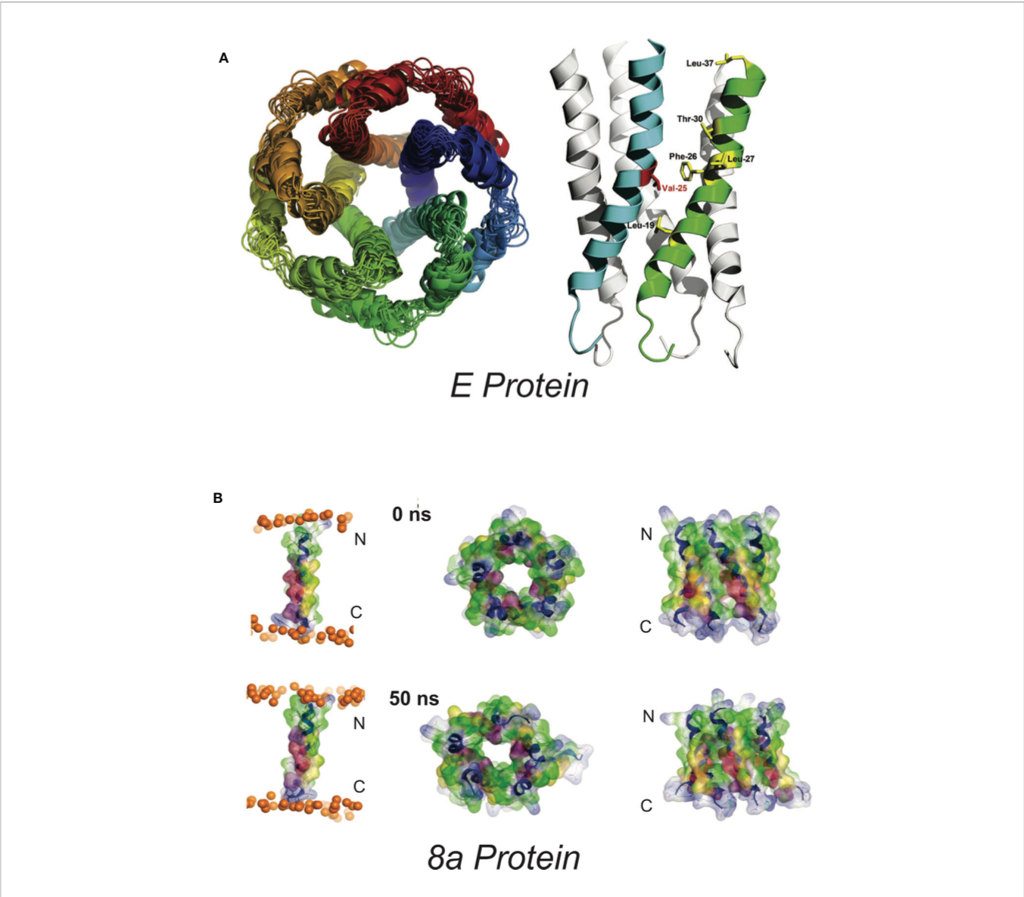

FIGURE 1 | Proposed SARS-Cov E and 8a structures (A) Proposed homopentameric structure of the E protein (32), viewed (left) through the membrane, and (right) on the plane of the membrane. The structural model includes a ~2Å radius constriction, formed by the sidechains of V25 and V28, which could conceivably act as a channel gate, and an extended central “pore” of <6Å in radius (34) [From Surya et al. BBA-Biomembranes 2018 1860: 1309-1317. With publisher’s permission] (B). Proposed pentameric structure of the 8a protein. (left) The single transmembrane domain (TMD) 8a 1–22 is shown at the beginning (0 ns) and end of a 50-ns MD simulation, (right). Top view (left) and side view (right) of a pentameric bundle of 8a 1–22 at the beginning (upper) and end of 50 ns MD simulation (lower). The protein backbones are drawn in blue with the side chains shown as sticks and van der Waals surface representation. Residues Thr-8, Ser-11, and 214 are shown in pink and light red, respectively. All cysteine residues, Cys-9, 213, and 217, are shown in yellow. Phosphorous atoms of the lipids are shown in orange spheres. Lipid and water molecules are omitted for clarity. [Relabeled from Hsu et al., Proteins. 2015; 83: 300–308. With publisher’s permission].

that the double mutant resulted in non-specific destabilization of the membrane. That V25F/A32F currents were amantadine- insensitive and reportedly displayed no ion selectivity, whereas WT-associated conductances showed selectivity for calcium over sodium (unfortunately no drug-sensitivity data was reported for N15A/V25F double mutants), was consistent with this interpretation. Incidentally, the relevant selectivity data [their Figure 5 in (35)] was interpreted as demonstrating selectivity for sodium over calcium but the methods state that membrane voltage referred to the cis- relative to the 4 trans-bilayer chamber, and CaCl2 was present in the trans- chamber, so the (~20 mV) positive shift in the reversal potential would be consistent with a preference for Ca2+ to Na+.

The calcium permeability of SARS-CoV E was further explored by the same group, who reported that negatively-charged lipids increased the permeability ratio for calcium over chloride (11). Lipid composition also affected E-associated monovalent ion conductances, with negatively charged lipids reducing apparent unitary conductance in KCl and increasing monovalent-cation selectivity over Cl−, compared with neutral membranes (44, 45).

a recent study using mouse-adapted (MA15) recombinant SARS showed no major effect of 8a deletion on virus titer in Vero E6 cells, virus growth in vivo in BALB/c mice, or mouse survival (9). Chen et al. (81) used in silico prediction of transmembrane topology and molecular dynamics simulations to propose multiple potential oligomultimers, including tetrameric-, pentameric-, and hexameric channel-like complexes, with hydrated pores lined by serine, threonine and cysteine residues (Figure 1). Subsequent MD simulations of pentameric 8a complexes were used for potential of mean force (PMF) calculations for Na+, K+, Cl−, and Ca2+ ions along the predicted permeation pathway (82). Similar peak PMF energy values around 2 kcal/mol were observed for all ions tested, yet Cl− ions permeated more readily under applied voltages — an effect attributed to a voltage- dependent widening of the pore during 50 ns permeation simulations which was not present in the brief PMF calculations. Experimental characterization of 8a has been limited to a single electrophysiological study of synthesized 8a peptide reconstituted into artificial lipid bilayers (81). Representative traces show noisy channel-like events and Ohmic behavior with low (~9 pS) conductance in symmetrical 300 mM KCl solutions. A ten-fold asymmetric elevation in ion concentration in the trans-chamber of the bilayer set-up resulted in an ~+30 mV shift in the reversal potential, which implies a weak cation-selectivity, in apparent conflict with the MD permeation studies and with the minor differences in peak energy barrier for cations and anions in PMF calculations (82). Unfortunately, the study again raises questions regarding overall interpretations: for example, it is not clear how the authors could reliably resolve the mean conductance in asymmetric ionic conditions given the tiny currents at the voltage cited (their Figure 2E).

**3a Ion Channel Activity**

3a was first claimed to be a K+ selective channel based on experiments showing the presence of Ba2+-sensitive K+ currents in transfected HEK293 cells (62), and in Xenopus oocytes injected with 3a cRNA (68). Appropriate shifts of K+ reversal potentials with asymmetric elevations in ion concentration corroborated K+ selectivity of the channel activity (18, 68–70). This correlation between two different expression systems strengthens the argument that 3a expression leads to appearance of a K+ conductance but, as noted above, such experiments cannot trivially exclude the possibility that the 3a protein activates an endogenous channel. For most ion channels, single-channel conductances provide a molecular “signature” that is unique and hence can define currents from endogenous or contaminant channels in recombinant expression systems. Unfortunately, while 3a expressed in oocyte membranes resulted in the appearance of a mild outwardly-rectifying single channel conductance, with a 90-pS slope conductance at positive potentials (in 100 mM KCl), strikingly different and varying properties were reported for 3a protein in bilayer experiments,

including currents with maximum conductance ~12 pS in symmetrical 500 mM KCl) and maximum conductance ~56 pS in symmetrical 500 mM CaCl2 (71). A ten-fold KCl gradient (500:50 mM, cis:trans) in the same study resulted in a ~15 mV shift in the reversal potential, indicative of a mild Cl− preference (71). Anion-replacement or large cation-replacement experiments would have been useful to rule out non-specific conductances through bilayer perturbation and demonstrate whether there was any true selectivity for different ion species. In sharp contrast, another study purified 3a from High-Five insect cells and performed single channel recordings in artificial bilayers, claiming to show a mild selectivity for monovalent cations (9), although, as noted, this was presented with a:representative trace” that had been attributed as a SARS-CoV E channel current in a previous publication (9, 45), seriously questioning the validity of these studies. Kern et al. have now functionally characterized the dimeric 3a proteins after reconstitution into synthetic liposomes (41). They analyzed reversal potential shifts in bi-ionic conditions to predict permeability ratios (PX/PK+): Ca2+ ~2 > K+ ~1 > Na+ ~0.6 > NMDG+ ~0.3, which is presumably based on the reported voltages referring to the pipette relative to the bath electrode (i.e. inverted from standard electrophysiological convention). The data indicate that reconstituted 3a protein generates a non-selective cationic channel potentially with a large pore (to accommodateNMDG+) and high single channel conductance (375 pS at – 80 mV). Permeation of large ions would likely require significant conformational changes from the resolved structure, given its narrow minimum pore radius. Of note is that single channel properties of 3a proteins were highly dependent on the permeating ions in particular with substantial flickering with Ca2+ and much smaller unitary conductances with NMDG+, Ca2+, and Na+ than with K+ ions, which suggests that the protein may undergo permeant ion-dependent conformational changes. Unexplained is how cation selectivity might arise: the cytoplasmic sites through which ion and water are proposed to enter the permeation pathways all exhibit positive potential (Figure 3); the inner cavity holds 5 basic residues per subunit while D142 is the only acidic residue in that space (Figure 3).

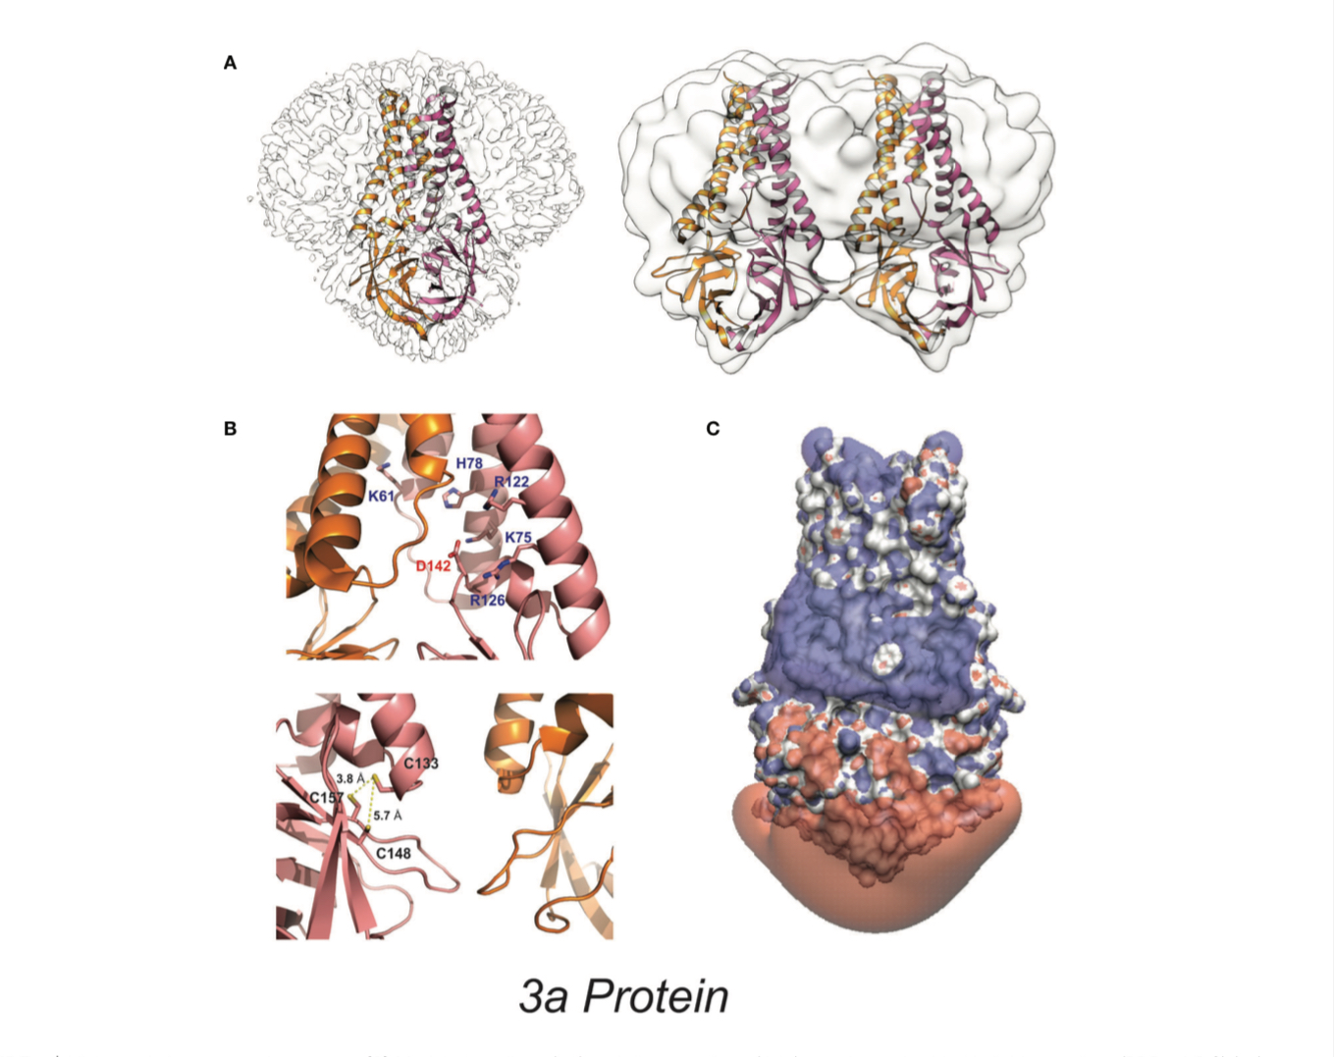

High-resolution 3a protein structure **(A)** Model of 3a dimer (left) and dimer-of-dimer (right) proteins embedded in lipid nanodiscs (PDB: 6XDC) (41). **(B)** (above) Location of charged residues within the cavity. (below) Location of cysteine residues near the dimer-dimer interface. **(C)** Space-filling model colored to

illustrate the isoelectric potential of the dimeric protein (+3 blue and −3 red) computed by PDB2PQR (42) and APBS (43) webservers with default settings.

**Literature :**

**There are 7 types of Neurofeedback for the treatment of various disorders:**

1-The most frequently used neurofeedback is frequency/power neurofeedback. This technique typically includes the use of 2 to 4 surface electrodes, sometimes called “surface neurofeedback”. It is used to change the amplitude or speed of specific brain waves in particular brain locations to treat ADHD, anxiety, and insomnia.

Slow cortical potential neurofeedback (SCP-NF) improves the direction of slow cortical potentials to treat ADHD, epilepsy, and migraines (Christiansen, Reh, Schmidt, & Rief, 2014).

2-Low-energy neurofeedback system (LENS) delivers a weak electromagnetic signal to change the patient’s brain waves while they are motionless with their eyes closed (Zandi-Mehran, Firoozabadi, & Rostami, 2014). This type of neurofeedback has been used to treat traumatic brain injury, ADHD, insomnia, fibromyalgia, restless legs syndrome, anxiety, depression, and anger.

3-Hemoencephalography (HEG) neurofeedback provides feedback on cerebral blood flow to treat migraine (Dias, Van Deusen, Oda, & Bonfim, 2012).

4-Live Z-score neurofeedback is used to treat insomnia. It introduces the continuous comparison of variables of brain electrical activity to a systematic database to provide continuous feedback (Collura, Guan, Tarrant, Bailey, & Starr, 2010).

5-Low-resolution electromagnetic tomography (LORE-TA) involves the use of 19 electrodes to monitor phase, power, and coherence (Pascual-Marqui, Michel, & Lehmann, 1994). This neurofeedback technique is used to treat addictions, depression, and obsessive-compulsive disorder.

6-Functional magnetic resonance imaging (fMRI) is the most recent type of neurofeedback to regulate brain activity based on the activity feedback from deep subcortical areas of the brain (Hurt, Arnold, & Lofthouse, 2014; Lévesque, Beauregard, & Mensour, 2006a).

**3a protein expression in membrane current :**

SARS-CoV is a newly identified coronavirus in humans that leads to a dangerous acute inflammation and is more lethal than other human coronaviruses (1–3). Beyond the four basic structural pro- teins, S, M, E, and N proteins, viral replicase, and protease, other structural and nonstructural proteins have not been fully studied. Identification of these viral proteins and understanding of their functions will help in development of effective drug candidates for SARS therapy.

The existence of 3a protein in both purified virus particles and virus-infected cell lysates has been reported (4, 6). Few studies have shown that the **3a protein** may be involved in cell apoptosis (15, 16) and may be released from virus-infected cells or 3a protein- transfected cells (17). In the present study we have demonstrated the antibody response to 3a protein in SARS patients and con- firmed the expression of 3a protein in SARS-CoV-infected cells. We have also analyzed its localization and structure on the cell membrane and found for the first time that 3a protein forms homodimers and homotetramers in transfected and possibly in infected cells. Localization of 3a protein on the membrane of virus-infected cells may be transient as a large part of it. 3a protein may be either incorporated into the virion (6) or released in the extracellular compartment in an unidentified form (17). Thus, in our experiments 3a could be identified and characterized only when it was expressed individually in transfected cells. However, process- ing of 3a protein in SARS-CoV-infected cells deserves further studies using pulse–chase experiments unaffordable in our bio- safety level 3 laboratory.

The tetrameric pattern is a very common feature of a protein involved in ion channel formation (18). Therefore, we tested whether the 3a protein could mediate channel-like activity by a two-electrode voltage clamp in Xenopus oocytes. Indeed, 3a protein expression resulted in a membrane current that was sensitive to potassium ions, suggesting the formation of a potassium-permeable channel-like structure. This idea was supported by the inhibitory

.

**Dynamic clamp constructed phase diagram of the Hodgkin-Huxley action potential model**

Excitability – a threshold governed transient in transmembrane voltage is a fundamental physiological process that controls the function of the heart, endocrine, muscles and neuronal tissues. The 1950’s Hodgkin and Huxley explicit formulation provides a mathematical framework for understanding excitability, as the consequence of the properties of voltage- gated sodium and potassium channels. The Hodgkin-Huxley model is more sensitive to parametric variations of protein densities and kinetics than biological systems whose excitability is apparently more robust. It is generally assumed that the model’s sensitivity reflects missing functional relations between its parameters or other components present in biologi- cal systems. Here we experimentally construct excitable membranes using the dynamic clamp and voltage-gated potassium ionic channels (Kv1.3) expressed in Xenopus oocytes. We take advantage of a theoretically de- rived phase diagram, where the phenomenon of excitability is reduced to two dimensions defined as combinations of the Hodgkin-Huxley model parameters. This biological-computational hybrid enabled us to explore functional relations in the parameter space, experimentally validate the phase diagram of the Hodgkin-Huxley model, and demonstrate activity- dependence and hysteretic dynamics due to the impacts of slow inacti- vation kinetics. The experimental results presented here provide new in- sights into the gap between technology-guided high-dimensional descrip- tions, and a lower, physiological dimensionality, within which biological function is embedded.

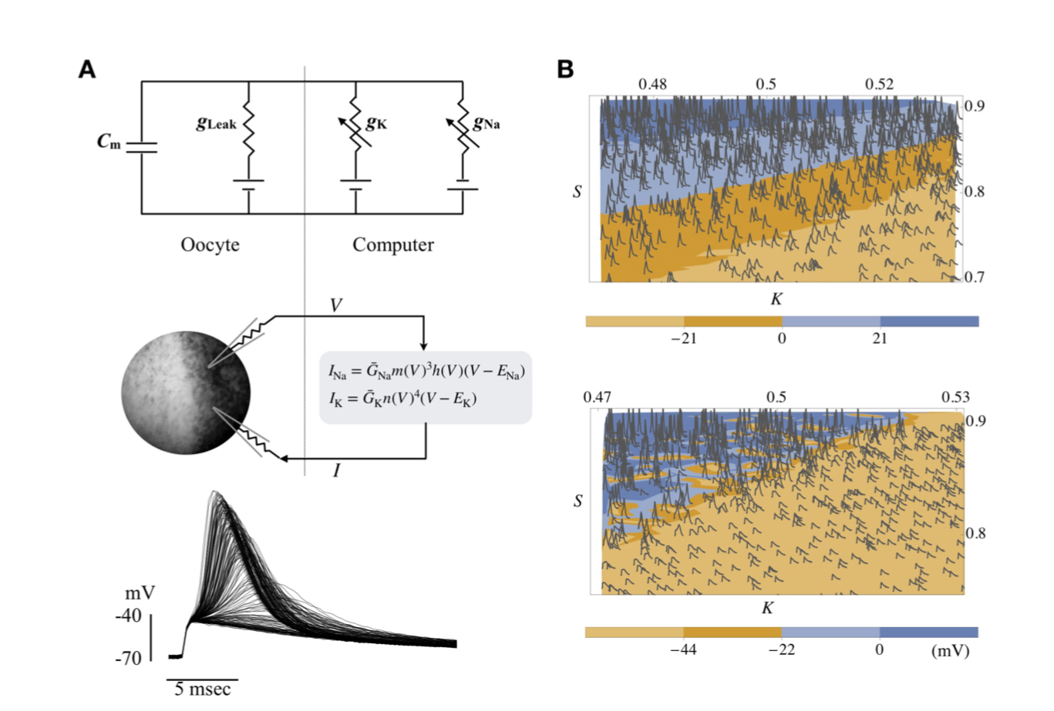

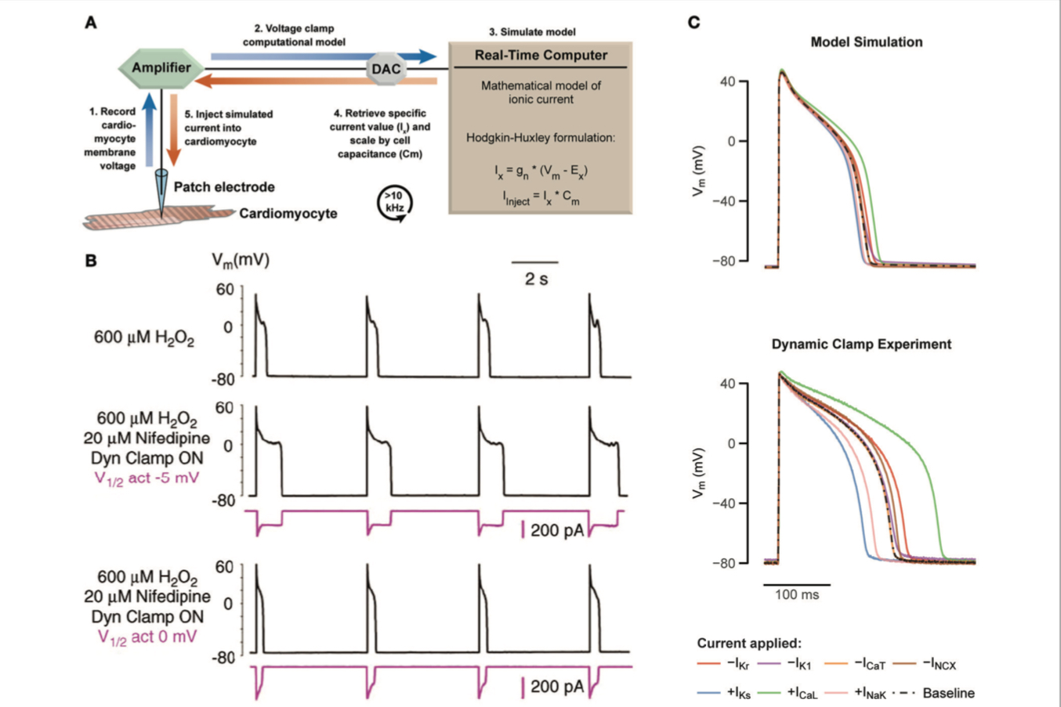

| Using dynamic patch clamp to reveal drug targets and systematically test computational models. (A) Schematic of the dynamic model clamp configuration. (B) Rabbit ventricular myocytes produce EADs during hydrogen peroxide exposure at a pacing cycle length of 5 s at 37◦ C (middle). Replacement of ICaL with a virtual conductance through dynamic clamp after block with nifedipine recapitulates appearance of EADs (middle). By varying the half-maximal of activation by 5 mV, EADs are abolished (bottom). Adapted with permission (Madhvani et al., 2011). (C) Prediction of a 40% increase or decrease of different cardiac currents based on a computational model of a ventricular guinea pig cardiomyocyte are tested with dynamic clamp, revealing a substantial mismatch. Adapted with permission

.

**General viroporin characteristics :**

‘Simplistic’ ion channels exhibiting channel–pore dualism

Viroporins rarely behave as classical voltage- or ligand- gated channels and lack the highly exclusive ion specificity displayed by cellular proteins. This is likely due to their inherent simplicity and the limited coding capacity of viruses, but has also led to scepticism concerning whether viroporins form true channels or merely non-specific pores across membranes. Often, weak ion selectivity and/ or indeterminate gating behaviour are evident in in vitro

or model cell systems, and ionic preferences are difficult to determine using standard electrophysiological techniques. Nevertheless, most viroporins do display at least a degree of selectivity, such as the IAV M2 proton channel where numerous structural and biophysical inves- tigations have defined its gating mechanism based on the ionization of a conserved His37 residue (Wang et al., 1995). However, M2 channels will also conduct potassium ions in vitro (Duff & Ashley, 1992), and render liposomes (Atkins et al., 2014) and bacterial cells (Guinea & Carrasco, 1994) permeable to fluorescent dyes and antibiotics, respectively. Other, less well characterized viroporins often reliably display preferences for, for example, cations over anions (or vice versa) in artificial bilayers (e.g. HIV- 1 Vpu, HCV p7), although defining the functionally rele- vant ionic species usually requires additional cell-based corroboration.

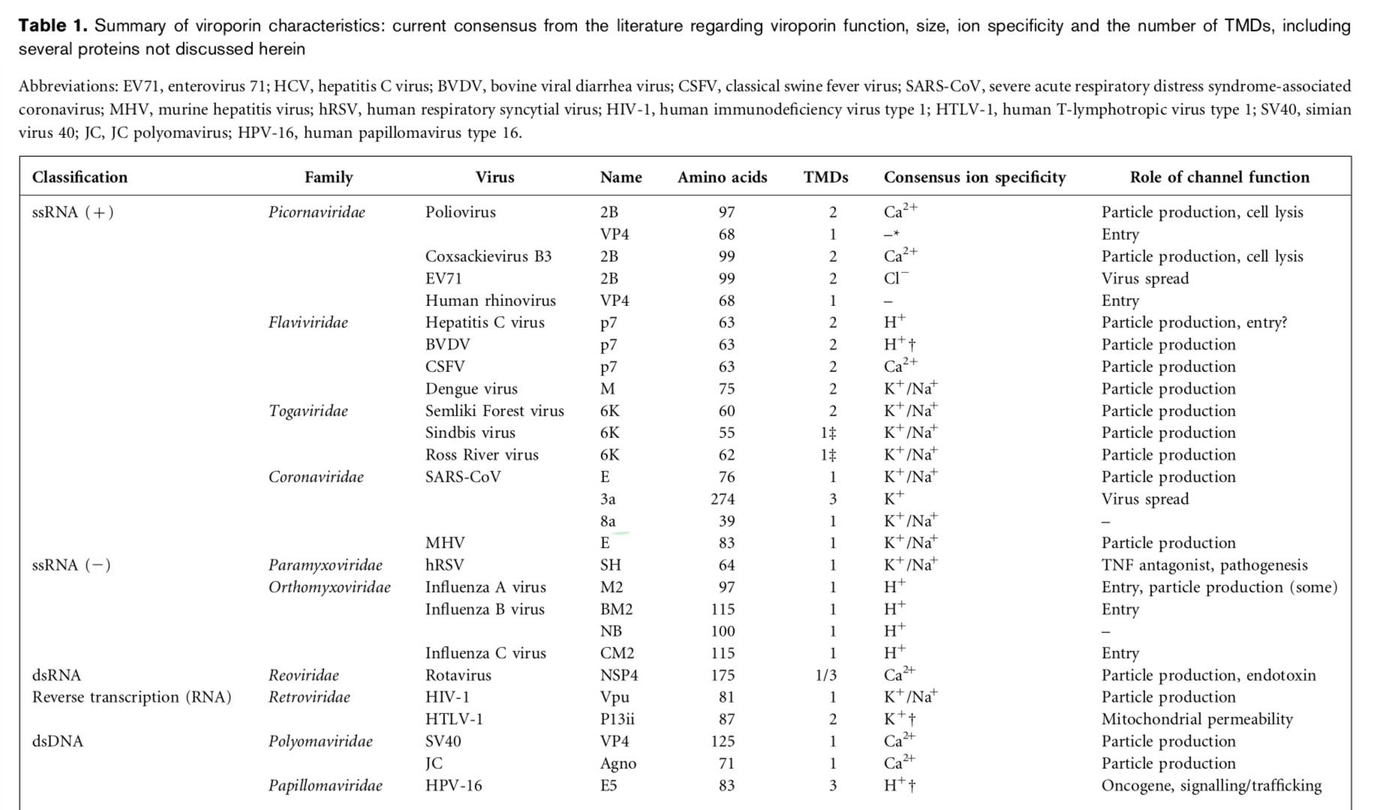

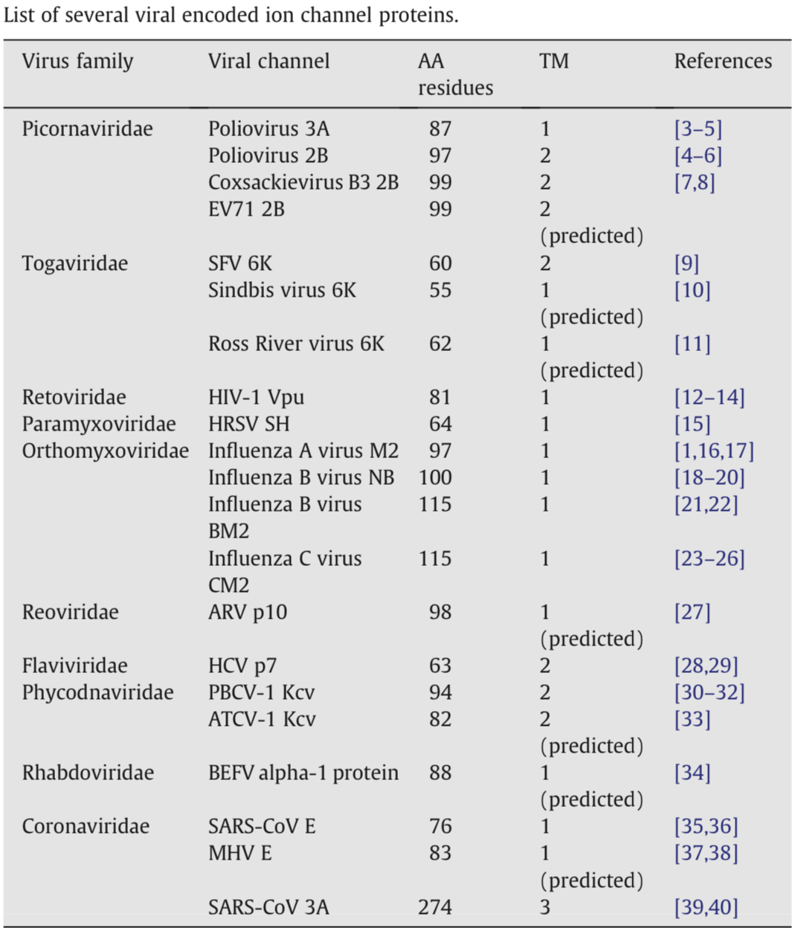

**Objective :**

**Detection of Accessory protein evoked response potentials in the piriform olfactory cortex electrophysiology regardings:**

The research aim to synthesis and simulation precisely of the signals which are tend to be produced by the discussed accessory protein in the real time . The idea is to detect the indication with machine learning prediction tool which reflect very an accurate result and evidence of that the patient is through exact SARS-COV2 case . We will use the approaches the are most the bio signal processing flows in the term of having the feature extracted from EEG waves in the real time , as python has developed package algoriyhem specified to read and analyze the brain waves in the real time called brain computer interface, our model has to be trained with the simulated SARS-COV2 accessory protein waves to calculate the spectral analysis of the trans membrane domain those are indicate prseense of the virus .

**step 1 :** Division of Biology and Biological Engineering, molecular electrophysiology laboratory to investigate the the viral structure protein and its current in the host cell membrane, studying the exact functions of those proteins in the ion channel reporting accurate electrophysiological screening and the set of events associated to the virus during binding stage ( mRNA proteins , Envelope protein ) during encoding aim to measure sodium and potassium current and the (spike train) of the virus the relevant event that might indicates whether the host cell certain receptor binding to virus spike or other ligand. The result To be carried to the second step .

Whole-cell recording has made investigations of channel selectivity much easier and more accurate than previously, and these methods have been used in many recent studies to probe the structure of channel pores.

Once the oldest beams of the ship have been inspected, we pro- ceed to the classic experiments of Hodgkin and Huxley, which are examined in detail in Chapter 5. This work provides a pre- lude to newer experiments on voltage-gated channels in Chapters 6 and 7. In a similar way, the experiments of Katz, Miledi, and their colleagues on synaptic transmission are used to place in con- text newer revelations about the proteins responsible for trans- mitter release (Chapter 8) and the postsynaptic receptors respon- sible for rapid excitatory and inhibitory transmission in the CNS (Chapters 9 and 10).

The remainder of the research follows these established themes and describes in the receptors, G proteins, effector molecules, and second messengers responsible for metabotropic synaptic transmission. We review many important biochemical discoveries about these molecules, not to provide a comprehensive treatment of the chemistry of the nervous system but rather to shed light on how these molecules regulate nerve cell behavior. This part of the research culminates in Chapter 14 with a description of cellular and molecular mechanisms of long-term potentiation.

We hope to show not only what we know but how we know it. Each chapter provides many individual experiments taken from the literature. Some of these (such as those of Hodgkin and Hux- ley) are well enough established to have entered the pantheon of the greats, and some are less well known but also illustrate the techniques and approaches that have formed our present view of nerve cell function. We have tried to describe these experiments in enough detail so that interested students can consult the published papers that contain them, and an extensive list of citations has been provided for this purpose.

Our goal is to explain the electrical activity of nerve cells in terms of their molecular components. Although it is not yet possible to provide as complete an explanation as one would like, much can be

**Tools : voltage patch clamp recording( xenopus oocyte), and Nanion technology (**Nanion is a leading provider of automated patch clamp (APC) electrophysiology systems with throughput capabilities ranging from a single cell up to fully automated high throughput screening (HTS) instruments recording from 384 cells simultaneously. Founded in 2002, Nanion has expanded its product range over the years to include in vitro systems for membrane pump and transporter recordings, bilayer recordings, and contractility measurements (impedance) from beating monolayers of cells, e.g. induced pluripotent stem cell-derived cardiac myocytes (iPSC-CMs), and confluency measurements of, e.g. hepatocytes for hepatotox screening using impedance.

**Step 2 :** computational neuroscience lab: to map the brain simulation with the observed data from step 1 fo confirmed infected person ., figuring out the neuronal networks afferent signals in the cortical motor and other responsible areas and nodes which involved in the certain activities of the virus , simultaneously we can address how the single virus or ligand sodium/ potassium current waves using neural dynamics modeling based EEG waves spectral analysis to observe the virus (spike train, binding membrane potential variability , ion gated channels probability with genome types consideration as there are several different synaptic behaviors genomic dependence ) . The data results to be carried to the third step . The approximately 100 billion neurons in our brain are responsible for everything we do and experience. Experiments aimed at discovering how these cells encode and process information generate vast amounts of data. These data span multiple scales, from interactions between individual molecules to coordinated waves of electrical activity that spread across the entire brain surface. To understand how the brain works, we must combine and make sense of these diverse types of information.

Computational modeling provides one way of doing this. Using equations, we can calculate the chemical and electrical changes that take place in neurons. We can then build models of neurons and neural circuits that reproduce the patterns of activity seen in experiments. Exploring these models can provide insights into how the brain itself works. Several software tools are available to simulate neural circuits, but none provide an easy way of incorporating data that span different scales, from molecules to cells to networks. Moreover, most of the models require familiarity with computer programming.

Dura-Bernal et al. have now developed a new software tool called NetPyNE, which allows users without programming expertise to build sophisticated models of brain circuits. It features a user-friendly interface for defining the properties of the model at molecular, cellular and circuit scales. It also provides an easy and automated method to identify the properties of the model that enable it to reproduce experimental data. Finally, NetPyNE makes it possible to run the model on supercomputers and offers a variety of ways to visualize and analyze the resulting output. Users can save the model and output in standardized formats, making them accessible to as many people as possible.

Researchers in labs across the world have used NetPyNE to study different brain regions, phenomena and diseases. The software also features in courses that introduce students to neurobiology and computational modeling. NetPyNE can help to interpret isolated experimental findings, and also makes it easier to explore interactions between brain activity at different scales. This will enable researchers to decipher how the brain encodes and processes information, and ultimately could make it easier to understand and treat brain disorders.

**Software tools :**

**1-**The NetPyNE tool (www.netpyne. org) provides both programmatic and graphical interfaces to develop data-driven multiscale network models in NEURON. NetPyNE clearly separates model parameters from implementation code. Users provide specifications at a high level via a standardized declarative language, for example connectivity rules, to create millions of cell-to-cell connections. NetPyNE then enables users to generate the NEURON network, run efficiently parallelized simulations, optimize and explore network parameters through automated batch runs, and use built-in functions for visualization and analysis – connectivity matrices, voltage traces, spike raster plots, local field potentials, and information theoretic measures. NetPyNE also facilitates model sharing by exporting and importing standardized formats (NeuroML and SONATA). NetPyNE is already being used to teach computational neuroscience students and by modelers to investigate brain regions and phenomena.

of neuronal dynamics with expertise in neurdynix and brain2 simulator packages .

**Step 3 : Brian computer interface :**

According to present understanding, the role of the central nervous system (CNS) is to respond to occurrences in the environment or in the body by producing appropriate outputs. The natural outputs of the CNS are either neuromuscular or hormonal. Correspondingly, the natural inputs of the CNS are from different sensory organs, peripheral nerves, internal hormones, etc. A brain–computer interface (BCI), which could interact with the CNS bidirectionally, gives the CNS new output that is not neuromuscular or hormonal or provides new inputs to the CNS, which could be direct stimulations to the CNS by injecting physical energy, such as deep brain stimulation (DBS), transcranial electrical stimulation (TES), transcranial magnetic stimulation (TMS), transcranial focused ultrasound (tFUS), or other forms of brain signal modulation. A BCI is a system that measures CNS activity and converts it into artificial output that replaces, restores, enhances, supplements, or improves natural CNS output; it can also be considered as a system to influence CNS activity and behavioral performance by injecting physical energy such as TES, TMS, tFUS, or direct brain signal modulation and thereby changes the ongoing interactions between the CNS and its external or internal environment.

To understand this definition, one needs to understand each of its key terms, starting with CNS. The CNS is composed of the brain and the spinal cord and is differentiated from the peripheral nervous system (PNS), which is composed of the peripheral nerves and ganglia and the sensory receptors. The unique features of CNS structures are their location within the meningeal coverings (i.e., meninges), their distinctive cell types and histology, and their role in integrating the numerous different sensory inputs to produce effective motor outputs. In contrast, the PNS is not inside the meninges, does not have the unique CNS histology, and serves primarily to bring sensory inputs to the CNS and to carry motor outputs from it.

CNS activity comprises electrophysiological, neurochemical, and metabolic phenomena (such as neuronal action potentials, synaptic potentials, neurotransmitter releases, and oxygen consumption) that occur continually in the CNS. These phenomena can be monitored by measuring electric or magnetic fields, hemoglobin oxygenation, or other parameters employing sensors on the scalp, on the surface of the brain, or within the brain. A BCI records brain signals, extracts particular measures (or features) from them, and converts (or translates) the features into new artificial outputs that act on the environment or on the body itself. Alternatively, a BCI system could also deliver physical energy directly to the brain through transcranial electrical, magnetic, acoustic stimulation or direct-current stimulation to the brain (e.g., DBS or direct cortical stimulation), to modulate the CNS to change the information- processing patterns within the brain and affect human behaviors.

Figure 4.1 illustrates the concepts of bidirectional BCIs, either controlling a device by the brain bypassing the common neuromuscular pathways or modulating and affecting the brain by injecting external physical energy.

A BCI output could replace natural output that has been lost to injury or disease. Thus, someone who cannot speak could use a BCI to spell words

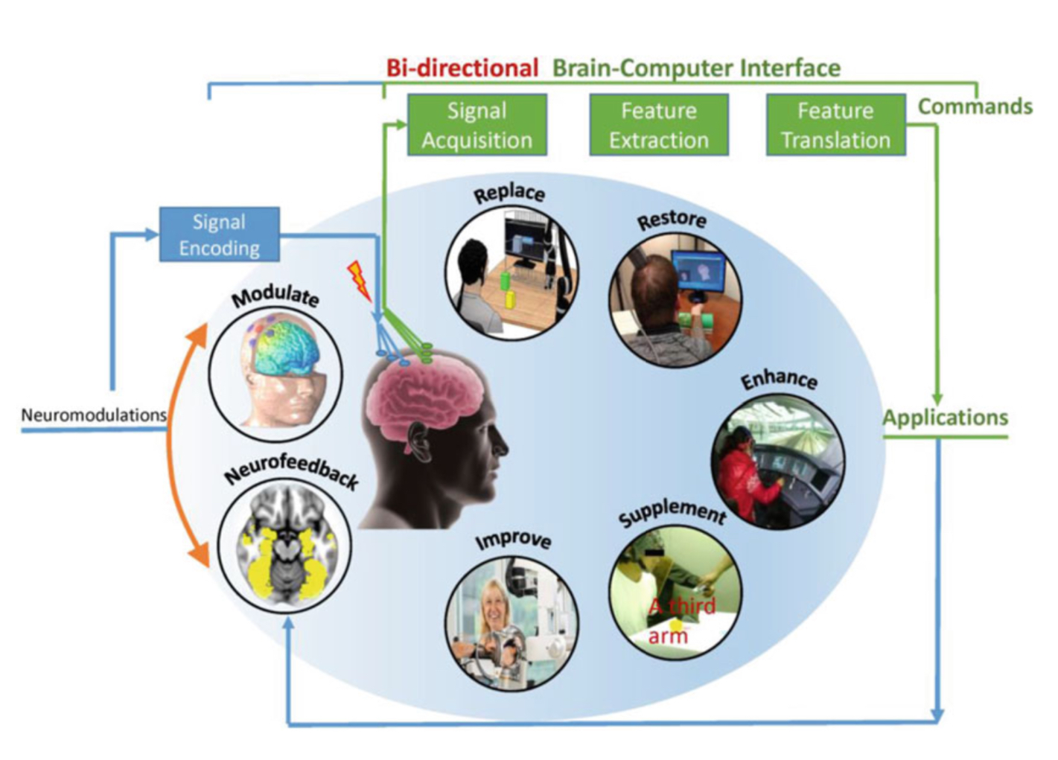

**Signal Acquisition and Processing**

BCI systems depend on the sensors and the related hardware that record the crucial brain signals. Improvements in this hardware are needed. EEG-based (noninvasive) BCIs should: have electrodes that do not need skin abrasion or conductive gel (i.e., so-called dry electrodes); be small and portable; use comfortable, convenient, and attractive mountings; be easy to set up; work for many hours without needing maintenance; work reliably in any environment; use telemetry rather than connecting wires; and interface easily with many different applications. Reliable performance in all relevant environments may be especially hard to ensure and should therefore be a major research goal. The biggest challenge for an EEG-based BCI maybe the further development of signal processing and machine learning techniques that can reliably and accurately decode and delineate the intention signals from relatively noisy EEG signals. This would require innovations in machine learning, signal processing, and classification algorithms, as well as advancement in systems neuroscience research.

BCIs that employ implanted electrodes (i.e., invasive BCIs) face a number of complex issues, some of which are not yet fully understood. These systems require hardware that: is safe and completely implantable; stays intact, functional, and reliable for many years; records stable signals for many years; transmits the recorded signals using telemetry; is able to be recharged in situ (or has batteries that last for many years); has external components that are durable, comfortable, con- venient, and unobtrusive; and interfaces readily with a range of high-performance applications. While considerable progress has been made in the past several years, it is not yet clear which possible solutions will be most successful, or how successful they can be. Fundamental innovations in sensor technology may be needed for invasive BCIs to achieve their full promise.

AI machine/deep learning engineering lab : will receive clear data concerns neuronal signals waves associated to viral mechanism of action, these data waves to be trained tested and predicted accurately modeled with deep learning (artificial neuronal networks) models based feature extraction and pattern recognition, as this step role to capture and identify the other (physiological, behavioral, psychological and behavioral reactions) accompanied to the viral infection process . The Lab will design software program can predict whether or not the patient EEG waves involve certain kind of virus neuronal electrophysiological behavior that are been reported in (step 1) , modeled , simulated with the corresponding interference brain area and the signal shape among the network noise and white noise in (step 2) and all to be supervised and unsupervised modeled in deep learning prediction model . Precisely we teach the computer how to recognise whether the virus wave existed in the( EEG) band waves with accuracy and real time basis, and statistical insights . At this step we deliver model that is adjustable and programmable to patient parameters and other neuronal signal propagation , the code to be injectable into small and portable microcontroller of very few digital components in electronic circuits , its well clarified in the proposal all is detailed up , at the next step , is the testing and operating

**Step 4 :**

At this stage we will be having all the scientific evidence and tool capabilities to detect whether or not people are infected with a certain viral infection within our database . We do the trials and testing observations with diversified patient categories and our metrics is the accuracy of the diagnosis with the supervision of clinical expertise , monitoring ,evaluating and manifesting the difficulties and risk management of the tool . If the outcomes are optimistic and accurate in the real time then we start the second part of design the stimulus based viral inhibition from the cortex motor to the host cells

**EEG analysis :**

Nonlinear analysis of EEG signals includes many measures that allow for extraction of useful information from dynamical systems. There are many methods of detecting dynamic changes in physiological systems; some complexity indexes in particular, such as Lempel– Ziv complexity [4], permutation Lempel–Ziv complexity [5], approximate entropy [6], sample entropy [7], fuzzy entropy [8], permutation entropy [9], multi-scale entropy [10–13], recurrence quantification analysis [14], detrended fluctuation analysis [15], and fractal dimension [16] are used as effective features of EEG signals [17–24].

Related researches have indicated that LZC [4] is powerful in analysing biomedical signals, especially in EEG analysis [25–29]. LZC based on a coarse-graining process is a nonlinear measure of signal complexity and irregularity for short and nonstationary time series. Higher value of LZC implies a more complex structure of the signal. The original Lempel–Ziv complexity algorithm consists of transformation of the signal into a binary sequence by comparing it with the threshold (e.g., mean or median) and cal- culating the unique subsequence in a sequence. However, the LZC measure is artifact sensitive and cannot distinguish between deterministic chaos and noise [5,30,31]. The binary coarse-graining process is associated with loss of signal dynamics and important system information. Ordinal patterns [9] have been used to quantify dynamical information of signals as an improvement of binary coarse-graining process. Bai et al. [5] developed permutation Lempel–Ziv complexity measures (PLZC) to quantify dynamic changes in EEG signals. However, the existing PLZC methods have one common problem when analyzing EEG signals: EEG information is embedded in different scale domains. PLZC algorithm is a single-scale analysis, and therefore, it fails to account for multiple electrical activities that are inherent in the brain. Using the multiscale approach to measure the complexity of EEG recordings over multiple time scales of signals instead of using a single scale [10] is a solution to this problem. Therefore, we proposed the multiscale permuta- tion Lempel–Ziv complexity measure (MPLZC) that combines permutation Lempel–Ziv complexity methods and a multiscale approach. The concept of multiscale Lempel–Ziv measure has already been introduced in the analysis of short, non-stationary, and noisy EEG signals [32]. However, this method uses multiple thresholds for binarization, which is obtained by comparing each element of EEG signals with its smoothed version

**The second step** as planed to have brain stimulation to inject signal in the neuron that inhabit the functions of the accessory protein by the modification and simulated stimulus based the the prediction result from the previous algorithm output of positive evidence of have the accessory protein function waves are detected within the EEG band waves . The model has to respond with pulse wave based (Huxley- Hodgkin ) -model that is espcified to simulate and measure the neuron action potential based the sodium , potassium , and Agcl . The ion channel of the host cell react based those three ions current and potassium, sodium in specific. Explained in the method and tools part the idea and components .

The response of the host cell to the pulse stimulation has to be tested and confirmed with safe inhabitision to the cell with no bad consequences to the brain as will discuss the deep brain stimulation reaction in the endocrine system and the other renal function. The renin aldestron angiotensgin system functions considered in this research .

Lab observation of those objectives have to be made accurately with robust and strong possabilties and modern technology to determine the dynamic clamp measurement of the cell ion current during the presence the virus accessory protein to be observed as spectral wave, and restored to the data set as target label in the model . And then search for this wave among the EEG band waves using spectral analysis algorithm called limpel- ziv model will do the task in the real time percicely . In the case of positive response indicate the wave existence, aim to stimuli with wave that are inhibit the the ion channel very safely , so all the algorithm have to work in the real time . We assume that will eliminate the proliferation of the virus .

**Methods / Tools and workflow :**

1- NetPyNE’s workflow consists of four main stages: (1) high-level specification, (2) network instantiation, (3) simulation and (4) analysis and saving (Figure 1). The first stage involves defining all the parameters required to build the network, from population sizes to cell properties to connectivity rules, and the simulation options, including duration, integration step, variables to record, etc. This is the main step requiring input from the user, who can provide these inputs either programmatically with NetPyNE’s declarative language, or by using the GUI. NetPyNE also enables importing of existing cell models for use in a network.

2- Human Neocortical Neurosolver (HNN) is a user-friendly software tool that provides a novel solution to this challenge. HNN gives researchers and clinicians the ability to test and develop hypotheses on the circuit mechanism underlying their EEG/MEG data in an easy-to-use environment. The foundation of HNN is a computational neural model that simulates the electrical activity of the neocortical cells and circuits that generate the primary electrical currents underlying EEG/MEG recordings. HNN can be run through an interactive graphical user interface (HNN-GUI) or through a command line python interface (HNN-Core). We provide tutorials on how to import your data and to begin to understand the underlying circuit mechanisms for both version of the software. We strongly recommending starting with the HNN-GUI tutorials, after which understanding the corresponding HNN-core python tutorials will be more accessible.

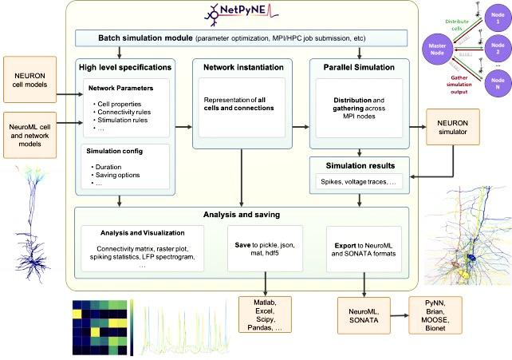

Overview of NetPyNE components and workflow.

Users start by specifying the network parameters and simulation configuration using a high-level JSON-like format. Existing NEURON and NeuroML models can be imported. Next, a NEURON network model is instantiated based on these specifications. This model can be simulated in parallel using NEURON as the underlying simulation engine. Simulation results are gathered in the master node. Finally, the user can analyze the network and simulation results using a variety of plots; save to multiple formats or export to NeuroML. The Batch Simulation module enables automating this process to run multiple simulations on HPCs and explore a range of parameter values

Action potentials were characterised by Hodgkin & Huxley in squid. They are a rapid regenera- tive change in membrane potential that is initially triggered by depolarization. The depolarization opens voltage-gated sodium channels and triggers a transient sodium current. Then as the mem- brane potential becomes positive, slower voltage-gated potassium channels open to repolarize the membrane to the resting potential. There is a refractory period of insensitivity to depolarization before another action potential can be generated. The action potential threshold is −50 to −55 mV (approached from more negative values) in many cells.

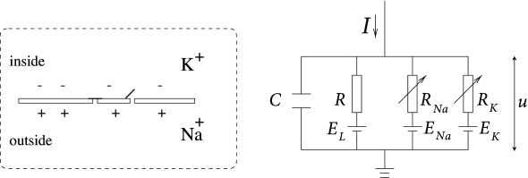

A schematic view of an idealized action potential illustrates its various phases as the action potential passes a point on a cell membrane.

channel models.

**Excitable membrane dynamics**

The neuron membrane acts as a boundary separating the intracellular fluid from the extracellu- lar fluid. It is selectively permeable allowing, for example, the passage of water but not large macromolecules. Ions (such as Na+, K+ and Cl−) can pass through the cell membrane, driven by diffusion and electrical forces, and this movement of ions underlies the generation and propagation of signals along neurons. Differences in the ionic concentrations of the intra/extracellular fluids create a potential difference across the cell. If the intra/extracellular potentials are denoted by Vout and Vin respectively, then the membrane potential is the potential difference across the membrane V = Vin − Vout.

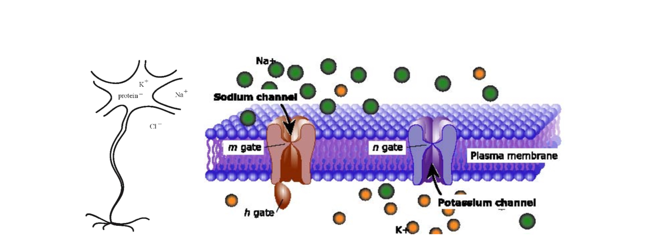

Left: Neurons are charged due to an unequal distribution of ions across the cell membrane. The

membrane of a neuron is said to be excitable and will support an action potential (right) in response to a sufficiently large input. Right: Ionic gates are embedded in the cell membrane and control the passage of ions.

• In the absence of a signal, there is a resting potential of ∼ −65mV.

• During an action potential, the membrane potential increase rapidly to ∼ 20mV, returns

slowly to ∼ −75mV and then slowly relaxes to the resting potential.

• The rapid membrane depolarisation corresponds to an influx of Na+ across the membrane. The return to −75mV corresponds to the transfer of K+ out of the cell. The final recovery stage back to the resting potential is associated with the passage of Cl− out of the cell.

**Synthetic Data**

Although modelling a signal as the EEG is difficult as a result of the complex nature of this biomedical signal, different efforts have been made. Mathematical models of EEG signals are often represented by a second-order non-linear differential equation; any coupling between two or more signals is also described by a strength parameter, often in the form of a further differential equation [28].

Therefore, to test the performance of dLZC, two coupled dynamical non-linear systems were used: a Rössler–Rössler system (no directionality) and a directed Rössler system driving a Lorenz system, as depicted in [29]. The driver is an autonomous Rössler system with:

which drives a Lorenz system with the coupling strength C = 8:

**Distance-Based Lempel–Ziv Complexity :**

A distance-based measure can be useful to identify the differences seen between pairs of signals. A true distance measure satisfies three main criteria [26]. If D(x, y) is the distance measure between signals x and y, these criteria can be identified as:

1-Non-negative, i.e., D(x, y) ≥ 0;

2-Symmetric, i.e., D(x, y) = D(y, x);

3-Satisfy the triangle inequality, i.e., D(x, y) ≤ D(x, z) + D(z, y )

By satisfying these three criteria, a distance-based measure makes no prior assumptions as to the path the information takes, and thus the location and timing of any signal similarities, around the brain.

This concept was used in [26] to introduce bivariate distance measures based on LZC. As well as successfully applying all five measures to construct a phylogenic tree based on mitochondrial DNA with only one misplacement, four of the five measures were also mathematically proven as distance measures within an appendix of [26].

However, we previously showed that there were some problems with the normalisation applied in the distances introduced by Otu and Sayood [26] when using them for the analysis of EEG signals in AD [31]. Therefore, the introduction of a new distance-based metric based on LZC is needed.

LZC complexity is based on the symbolisation of the original time series. This involves converting the original time series into a discrete sequence with a finite number of symbols in a coarse-graining stage. In this pilot study the EEGs were converted into binary sequences using the median as the threshold Td. In this coarse-graining step, a sequence P = s(1), s(2), . . . , s(n) is created by comparing the samples from the original sampled signal x(i) with the threshold, with s(i) given by:

{0 if x(i) < Td

s(i) = {1 if x(i) ≥ Td

To compute the LZC from this binary sequence, P has to be scanned from left to right and a complexity counter is increased every time a new subsequence is found. A detailed description of the LZC parsing algorithm can be found in [32].

The aforementioned complexity algorithm would return a complexity value that is dependent on the length of the sequence being scanned. Therefore, the complexity counter must be normalised against its upper bound to create comparable results [19]. For a binary sequence of length n.

In order to extend the concept of LZC to pairs of signals, we introduce dLZC. If a signal x(n) is coarse-grained to form a binary sequence P and signal y(n) to form a binary sequence Q, dLZC can be computed .

**conclusion :**

We aim to develop new device that recognise the signal potential of the virus protein in the real time of the cell being infected . Then the dynamic clamp model has to manipulate the signal with the virus protein resistance based the ion Chanel current that will be observed to prevent the membrane premability and eliminate the virus RNA to encode it self .

We use the tool spectral analysis of the EEG waves to have a very critical analysis of the multiple waves using a simulated signal that are recorded in our software , It enable us to I dentify whether the waves containing the signal we looking for or not . The idea might be little bit complicated but it’s possible and it deserve the trial .

**recommendation :**

Design portable device with proper head with EEG electrodes from inside the cover and mobile microcontroller with all the algorithms we discussed in this research .

The idea might sound complicated but it’s possible that one day people go the pharmacy and buy portable therapeutic device with a light weight as the pacemaker and artificial cardiac devices and other several instruments .

**References**

**1- McClenaghan C, Hanson A, Lee S-J and Nichols CG (2020) Coronavirus Proteins as Ion Channels: Current and Potential Research. Front. Immunol. 11:573339. doi: 10.3389/fimmu.2020.573339**

**2- Chen IY, Moriyama M, Chang MF and Ichinohe T (2019) Severe Acute Respiratory Syndrome Coronavirus Viroporin 3a Activates the NLRP3 Inflammasome. Front. Microbiol. 10:50. doi: 10.3389/fmicb.2019.00050**

**3- Redondo N, Zald ́ıvar-Lo ́ pez S, Garrido JJ and Montoya M (2021) SARS-CoV-2 Accessory Proteins in Viral Pathogenesis: Knowns and Unknowns. Front. Immunol. 12:708264. doi: 10.3389/fimmu.2021.70826**

**4- Lempel, A.; Ziv, J. On the complexity of finite sequences. IEEE Trans. Inf. Theory 1976, 22, 75–81. [CrossRef]**

**5- Bai, Y.; Liang, Z.; Li, X. A permutation Lempel-Ziv complexity measure for EEG analysis. Biomed. Signal Process. Control. 2015,**

**19, 102–114. [CrossRef]**

**6. Pincus, S.M. Approximate entropy as a measure of system complexity. Proc. Natl. Acad. Sci. USA 1991, 88, 2297–2301. [CrossRef]**

**7. Richman, J.S.; Moorman, J.R. Physiological time-series analysis using approximate entropy and sample entropy. Am. J. Physiol.**

**Heart Circ. Physiol. 2000, 278, H2039–H2049. [CrossRef]**

**8. Chen, W.; Zhuang, J.; Yu, W.; Wang, Z. Measuring complexity using fuzzyen, apen, and sampen. Med. Eng. Phys. 2009, 31, 61–68. [CrossRef]**

**9. Bandt, C.; Pompe, B. Permutation entropy: A natural complexity measure for time series. Phys. Rev. Lett. 2002, 88, 174102. [CrossRef]**

**10. Costa, M.; Goldberger, A.L.; Peng, C.-K. Multiscale entropy analysis of complex physiologic time series. Phys. Rev. Lett. 2002, 89, 068102. [CrossRef]**

**11. Ahmed, M.U.; Mandic, D.P. Multivariate multiscale entropy: A tool for complexity analysis of multichannel data. Phys. Rev. E 2011, 84, 061918. [CrossRef]**

**12. Ouyang, G.; Dang, C.; Li, X. Complexity analysis of EEG data with multiscale permutation entropy. In Advances in Cognitive Neurodynamics (II); Springer: Berlin/Heidelberg, Germany, 2011; pp. 741–745.**

**13. Zheng, J.-D.; Chen, M.; Cheng, J.-S.; Yang, Y. Multiscale fuzzy entropy and its application in rolling bearing fault diagnosis. J. Vib. Eng. 2014, 27, 145–151.**

**14- Ortega FA, Grandi E, Krogh-Madsen T and Christini DJ (2018) Applications of Dynamic Clamp to Cardiac ArrhythmiaPhysiol. 8:1099. doi: 10.3389/fphys.2017.01099**

**15. Agre P, Preston GM, Smith BL, et al. Aquaporin CHIP: the archetyp- al molecular water channel. Am J Physiol. 1993;265(4 Pt 2):F463-**

**16- Mookherjee, N., Anderson, M.A., Haagsman, H.P. & Davidson, D.J. Antimicrobial host defence peptides: functions and clinical potential. Nature Reviews Drug discovery 19, 311-332 (2020**

**17- Paulsen, Department of Physiology, Development and Neuroscience,University of Cambridge, Cambridge CB2 3EG, UK.DOI:10.1523/JNEUROSCI.3403-12.20**

**Biography**

Master in Business Administration (MBA) with Specialization in (general Management) 21014-2016 from (segi university , kuala lumpur , Malaysia)

Diploma in english language (segi university , kuala Lumpur , Malaysia)

Bachelors of Engineering- Biomedical (B.E) in the year( 2005-2010) from University of science and technology (Omdurman).

Higher Secondary from (almutafoqoon secondary school) 2003-2005)

elementary school went to ( elmorda Omdurman,  and almuhandesseen private school )

**Training :**

Excessive  training course in medical electronics  . (Mavec for biomedical equipment )egypt 2017. Certified .

Certification on project management training course , and committed to seat  (PMP) exam by the end of the year .

Medical military hospital 19-2-2009 to 19-3-2010

Another training at military hospital concerns the service managemnt from (11-4-2011 to 11-5-2011) .

Bahry educational hospital concern workshop management  from(14-12-2011 to 4-3-2012 ) .

**Working Experience :**

* Research collaborative : university of medical sciences and technology , Biomedical engineering faculty and medical research Center.
* Researcher and Program assistant at unesco ecotechnique chair in future university from 2th march 2019 up to now .
* environmental biotechnology researcher and contact point person for (smart innovation lab) in canada as stabilishing research together in the area of data science digital image processing applications and machine learning) . Currrent job .
* Military service period in pharmaceutical manufacturing lab as biomedical service director (karary military university) (April 2018 to April 2019).
* Senior lecturer at business school of several universities

From jan 2017 up to now . Current job .

* .Biomedical Engineer assistant at the management department and Process Facilitator 2014
* Worked to (Almostaqbal Hospital Management Services Ltd. as Biomedical Engineer (Jeddah Saudi Arabia), the three months of trial  2012.

**Personal details :**

* **Full name : Hassan adel hassan gobara**
* **Date of birth : 1st January 1988**
* **Designation : researcher and Biomedical engineer .**
* **Email :** [**Hassangobara2@gmail.com**](mailto:Hassangobara2@gmail.com)
* **Phone number: +249907810150**
* **Research interest : biotechnology and molecular biotechnology .**